CPE301 – SPRING 2019

Midterm 2

Student Name: Allis Hierholzer

Student #: 2000160356

Student Email: hierholz@unlv.nevada.edu

Primary Github address: https://github.com/acexhp/submission_da.git

Directory: Repository/cpe301/DesignAssignment/Midterm2

Task:

Q: Write, simulate, and demonstrate using Atmel Studio 7 a C code for the AVR ATMEGA328p microcontroller that performs the following functions:

1. Program the I2C of ATmega328/p to read RGB/Ambient Light data from APDS 9960 sensor.

2. Display the value to UART.

3. Make sure the AT Firmware is downloaded into the ESP-01/ESP32 module.

4. Register for a free Thingspeak account with MATHWORK. Setup and get the channel Key.

5. Transmit Lux sensor value to ESP-01/ESP32 through UART port using AT Commands.

6. Display the Lux sensor value as a graph in Thingspeak

Submission:

The following are required for successful completion of the design assignment:

a. AVR C code that has been compiled and working.

b. The C code should be well documented with explanation of every instruction.

c. A word document that contains the flow chart of the assembly code along with the screenshots/snapshot of the Atmel Studio 7 and/or live connections during debugging at the beginning and end of Task 1-6.

d. Submit one solution folder, with doc and video/snapshot file.

1. **COMPONENTS LIST AND CONNECTION BLOCK DIAGRAM w/ PINS**

* Breadboard
* Wires
* USB Cables
* Multi-functional shield
* ATMEL STUDIO 7.0
* APDS9960 Sensor
* ESP-32

1. **INITIAL/MODIFIED/DEVELOPED CODE OF TASK 1/A**

/*

* Midterm2.c

*/

#define F_CPU 16000000UL

#include <avr/io.h>

#include <util/delay.h>

#include <stdio.h>

#include "i2c_master.h"

#include "uart.h"

#include "apds.h"

#define BAUD 9600

#define BRGVAL (F_CPU/16/BAUD) - 1

#ifndef APDS_H

#define APDS_H

#include <avr/io.h>

#include "i2c_master.h"

#include "apds.h"

#define APDS_WRITE (0x39 << 1) | 0

#define APDS_READ (0x39 << 1) | 1

//APDS-9960 I2C address

#define APDS9960_I2C_ADDR 0x39

#define ERROR 0xFF

//Device ID

#define APDS9960_ID_1 0xAB

#define APDS9960_ID_2 0x9C

//Parameters

// Wait -- FIFO reads

#define FIFO_PAUSE_TIME 30

//APDS-9960 register addresses

#define APDS9960_ENABLE 0x80

#define APDS9960_ATIME 0x81

#define APDS9960_WTIME 0x83

#define APDS9960_PERS 0x8C

#define APDS9960_CONFIG1 0x8D

#define APDS9960_PPULSE 0x8E

#define APDS9960_CONFIG2 0x90

#define APDS9960_ID 0x92

#define APDS9960_RDATAL 0x96

#define APDS9960_RDATAH 0x97

#define APDS9960_GDATAL 0x98

#define APDS9960_GDATAH 0x99

#define APDS9960_BDATAL 0x9A

#define APDS9960_BDATAH 0x9B

#define APDS9960_POFFSET_UR 0x9D

#define APDS9960_POFFSET_DL 0x9E

#define APDS9960_CONFIG3 0x9F

//Bit fields

#define APDS9960_PON 0x01

#define APDS9960_AEN 0x02

#define APDS9960_PEN 0x04

#define APDS9960_WEN 0x08

#define APSD9960_AIEN 0x10

#define APDS9960_PIEN 0x20

#define APDS9960_GEN 0x40

#define APDS9960_GVALID 0x01

//Power On/Off

#define OFF 0

#define ON 1

//Parameter SetMode

#define POWER 0

#define AMBIENT_LIGHT 1

//Proximity

#define WAIT 3

#define AMBIENT_LIGHT_INT 4

#define ALL 7

//LED Drive values

#define LED_DRIVE_100MA 0

#define LED_DRIVE_50MA 1

#define LED_DRIVE_25MA 2

#define LED_DRIVE_12_5MA 3

//LED Boost values

#define LED_BOOST_100 0

#define LED_BOOST_150 1

#define LED_BOOST_200 2

#define LED_BOOST_300 3

//Default values

#define DEFAULT_ATIME 219

#define DEFAULT_WTIME 246

#define DEFAULT_PROX_PPULSE 0x87

#define DEFAULT_POFFSET_UR 0

#define DEFAULT_POFFSET_DL 0

#define DEFAULT_CONFIG1 0x60 //wait (WTIME) factor

#define DEFAULT_LDRIVE LED_DRIVE_100MA

#define DEFAULT_PGAIN PGAIN_4X

#define DEFAULT_AGAIN AGAIN_4X

#define DEFAULT_AILT 0xFFFF //Force interrupt for calibration

#define DEFAULT_AIHT 0

#define DEFAULT_PERS 0x11 //Two consecutive prox or ALS for int.

#define DEFAULT_CONFIG2 0x01 //No Saturation/LED boost

#define DEFAULT_CONFIG3 0 //Enable all photodiodes

#define DEFAULT_GLDRIVE LED_DRIVE_100MA

#define DEFAULT_GWTIME GWTIME_2_8MS

void initialize_APDS();

void Color_detector();

#endif

*FILE* str_uart = *FDEV_SETUP_STREAM*(uart_char, *NULL* , *_FDEV_SETUP_WRITE*);

char results[256];

void initialize_UART();

int uart_char( char c, *FILE* *stream);

int main(void)

{

*uint16_t* red = 0, green = 0, blue = 0;

i2c_init();

initialize_UART();

*stdout* = &str_uart;

initialize_APDS();

*_delay_ms*(2000);

*printf*("AT\r\n");

*_delay_ms*(3000);

*printf*("AT+CWMODE=1\r\n");

*_delay_ms*(3000);

*printf*("AT+CWJAP=\"Higbee_Pixel\",\"Higbee19\"\r\n");

while (1)

{

*_delay_ms*(3000);

*printf*("AT+CIPMUX=0\r\n");

*_delay_ms*(3000);

*printf*("AT+CIPSTART=\"TCP\",\"api.thingspeak.com\",80\r\n");

*_delay_ms*(3000);

Color_detector(&red, &green, &blue);

*printf*("AT+CIPSEND=104\r\n");

*printf*("GET https://api.thingspeak.com/update?api_key=8J8ALHG02UEU5SVN&field1=%05u&field2=%05u&field3=%05u\r\n", red, green, blue);

*_delay_ms*(3000);

}

}

void initialize_APDS(){

*uint8_t* setup;

i2c_readReg(APDS_WRITE, APDS9960_ID, &setup,1);

if(setup != APDS9960_ID_1) while(1);

setup = 1 << 1 | 1<<0 | 1<<3 | 1<<4;

i2c_writeReg(APDS_WRITE, APDS9960_ENABLE, &setup, 1);

setup = DEFAULT_ATIME;

i2c_writeReg(APDS_WRITE, APDS9960_ATIME, &setup, 1);

setup = DEFAULT_WTIME;

i2c_writeReg(APDS_WRITE, APDS9960_WTIME, &setup, 1);

setup = DEFAULT_PROX_PPULSE;

i2c_writeReg(APDS_WRITE, APDS9960_PPULSE, &setup, 1);

setup = DEFAULT_POFFSET_UR;

i2c_writeReg(APDS_WRITE, APDS9960_POFFSET_UR, &setup, 1);

setup = DEFAULT_POFFSET_DL;

i2c_writeReg(APDS_WRITE, APDS9960_POFFSET_DL, &setup, 1);

setup = DEFAULT_CONFIG1;

i2c_writeReg(APDS_WRITE, APDS9960_CONFIG1, &setup, 1);

setup = DEFAULT_PERS;

i2c_writeReg(APDS_WRITE, APDS9960_PERS, &setup, 1);

setup = DEFAULT_CONFIG2;

i2c_writeReg(APDS_WRITE, APDS9960_CONFIG2, &setup, 1);

setup = DEFAULT_CONFIG3;

i2c_writeReg(APDS_WRITE, APDS9960_CONFIG3, &setup, 1);

}

void readColor(*uint16_t* *red, *uint16_t* *green, *uint16_t* *blue){

*uint8_t* redl, redh;

*uint8_t* greenl, greenh;

*uint8_t* bluel, blueh;

i2c_readReg(APDS_WRITE, APDS9960_RDATAL, &redl, 1);

i2c_readReg(APDS_WRITE, APDS9960_RDATAH, &redh, 1);

i2c_readReg(APDS_WRITE, APDS9960_GDATAL, &greenl, 1);

i2c_readReg(APDS_WRITE, APDS9960_GDATAH, &greenh, 1);

i2c_readReg(APDS_WRITE, APDS9960_BDATAL, &bluel, 1);

i2c_readReg(APDS_WRITE, APDS9960_BDATAH, &blueh, 1);

*red = redh << 8 | redl;

*green = greenh << 8 | greenl;

*blue = blueh << 8 | bluel;

}

void initialize_UART(void){

//Set baud rate

*uint16_t* baud_rate = BRGVAL;

UBRR0H = baud_rate >> 8;

UBRR0L = baud_rate & 0xFF;

//Enable receiver/transmitter

UCSR0B = ( 1 <<RXEN0)|( 1 <<TXEN0);

//Set frame format

UCSR0C = (3 <<UCSZ00);

}

int uart_char(char c, *FILE* *stream){

//Empty buffer

while ( !( UCSR0A & ( 1 <<UDRE0)) );

//Data to buffer

UDR0 = c;

return 0;

}

1. **SCHEMATICS**

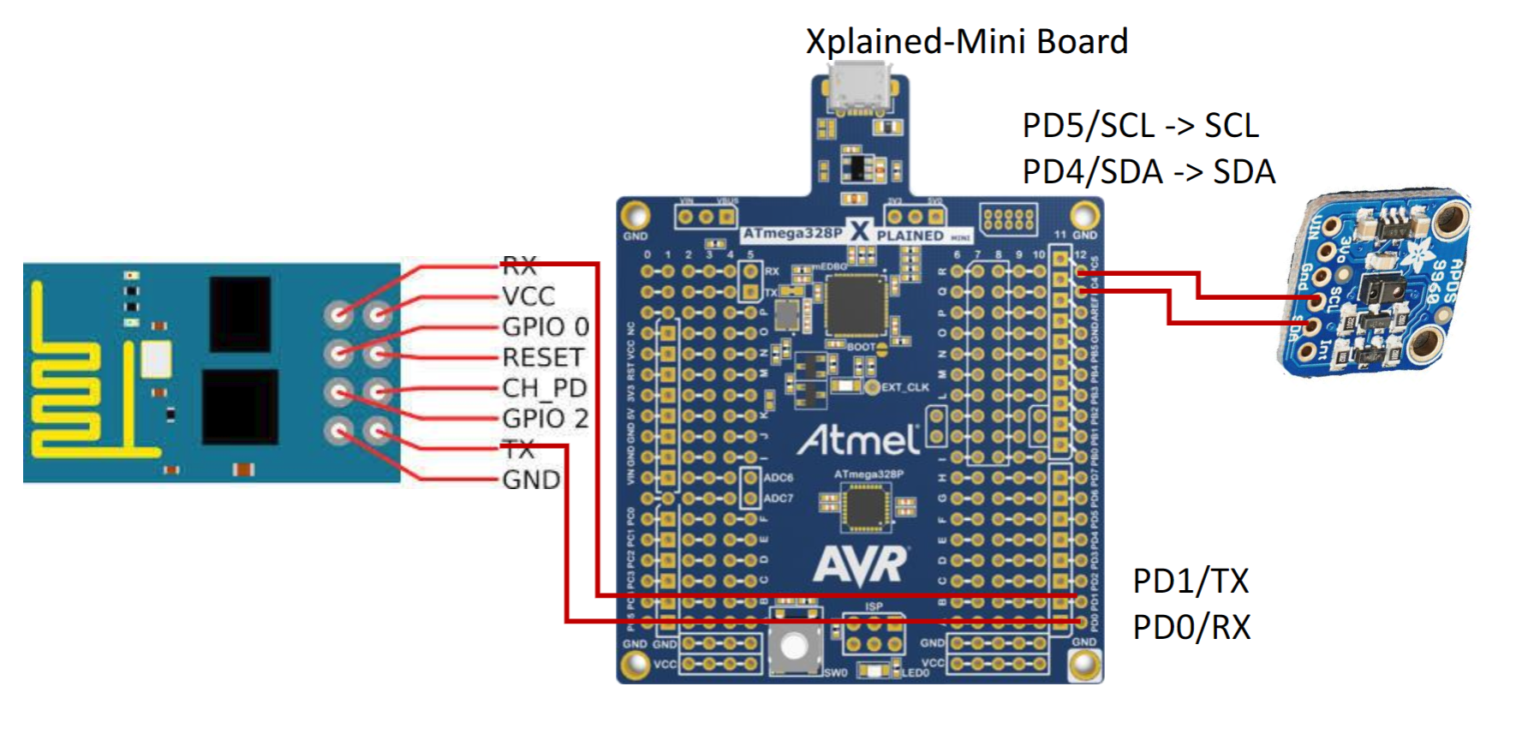

1. **SCREENSHOTS OF EACH TASK OUTPUT (OUTPUT)**

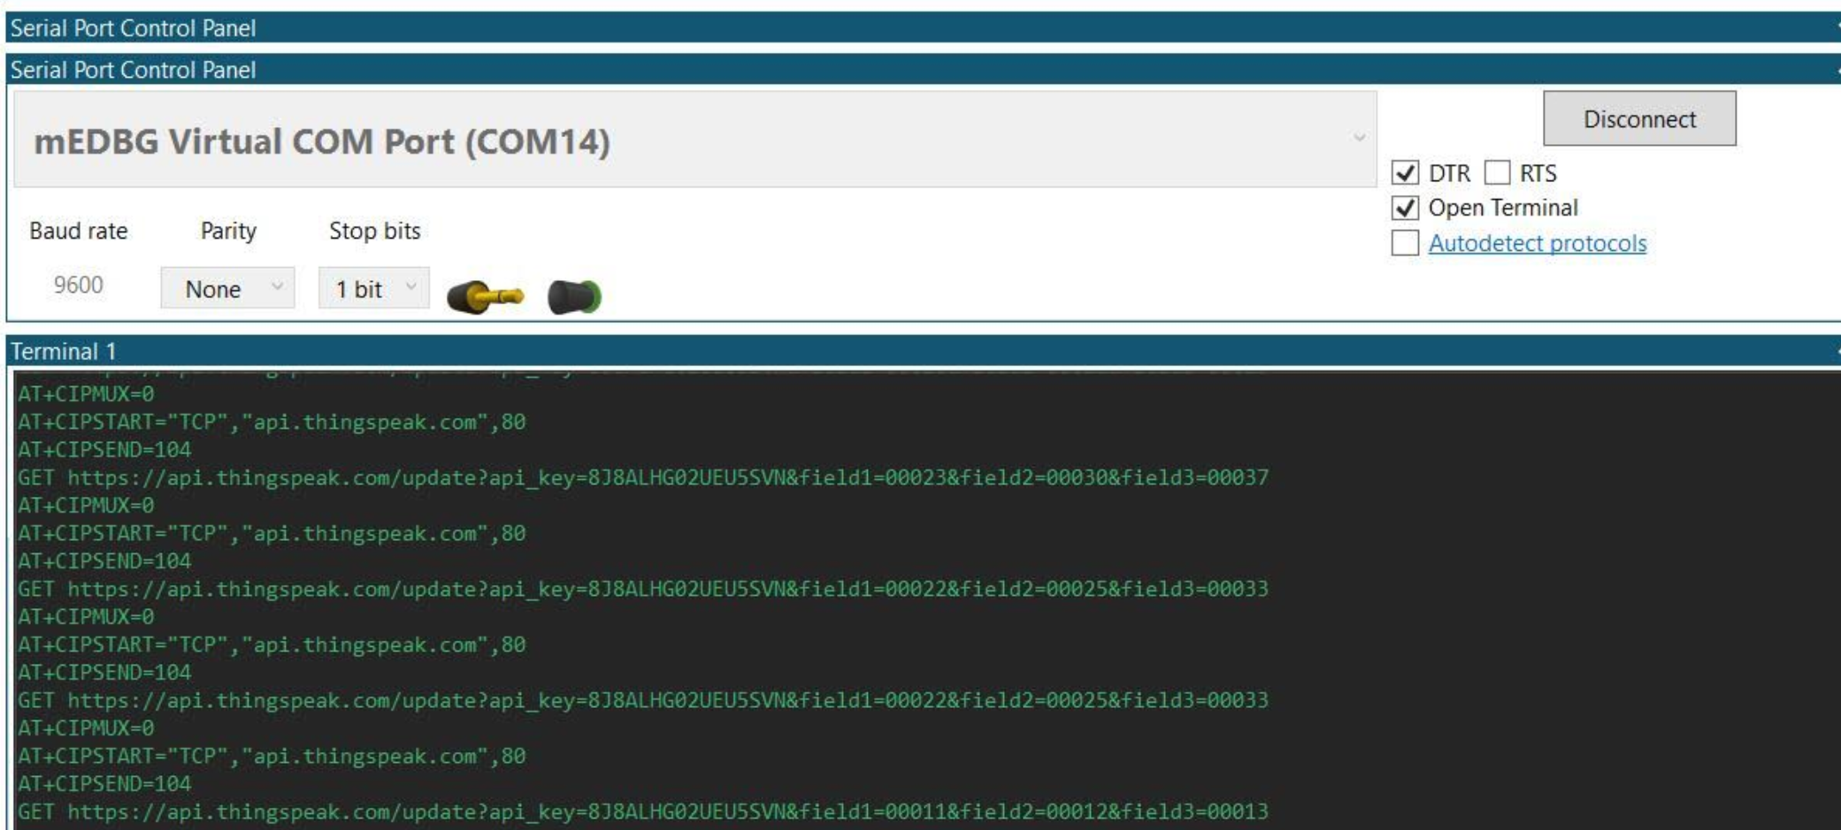

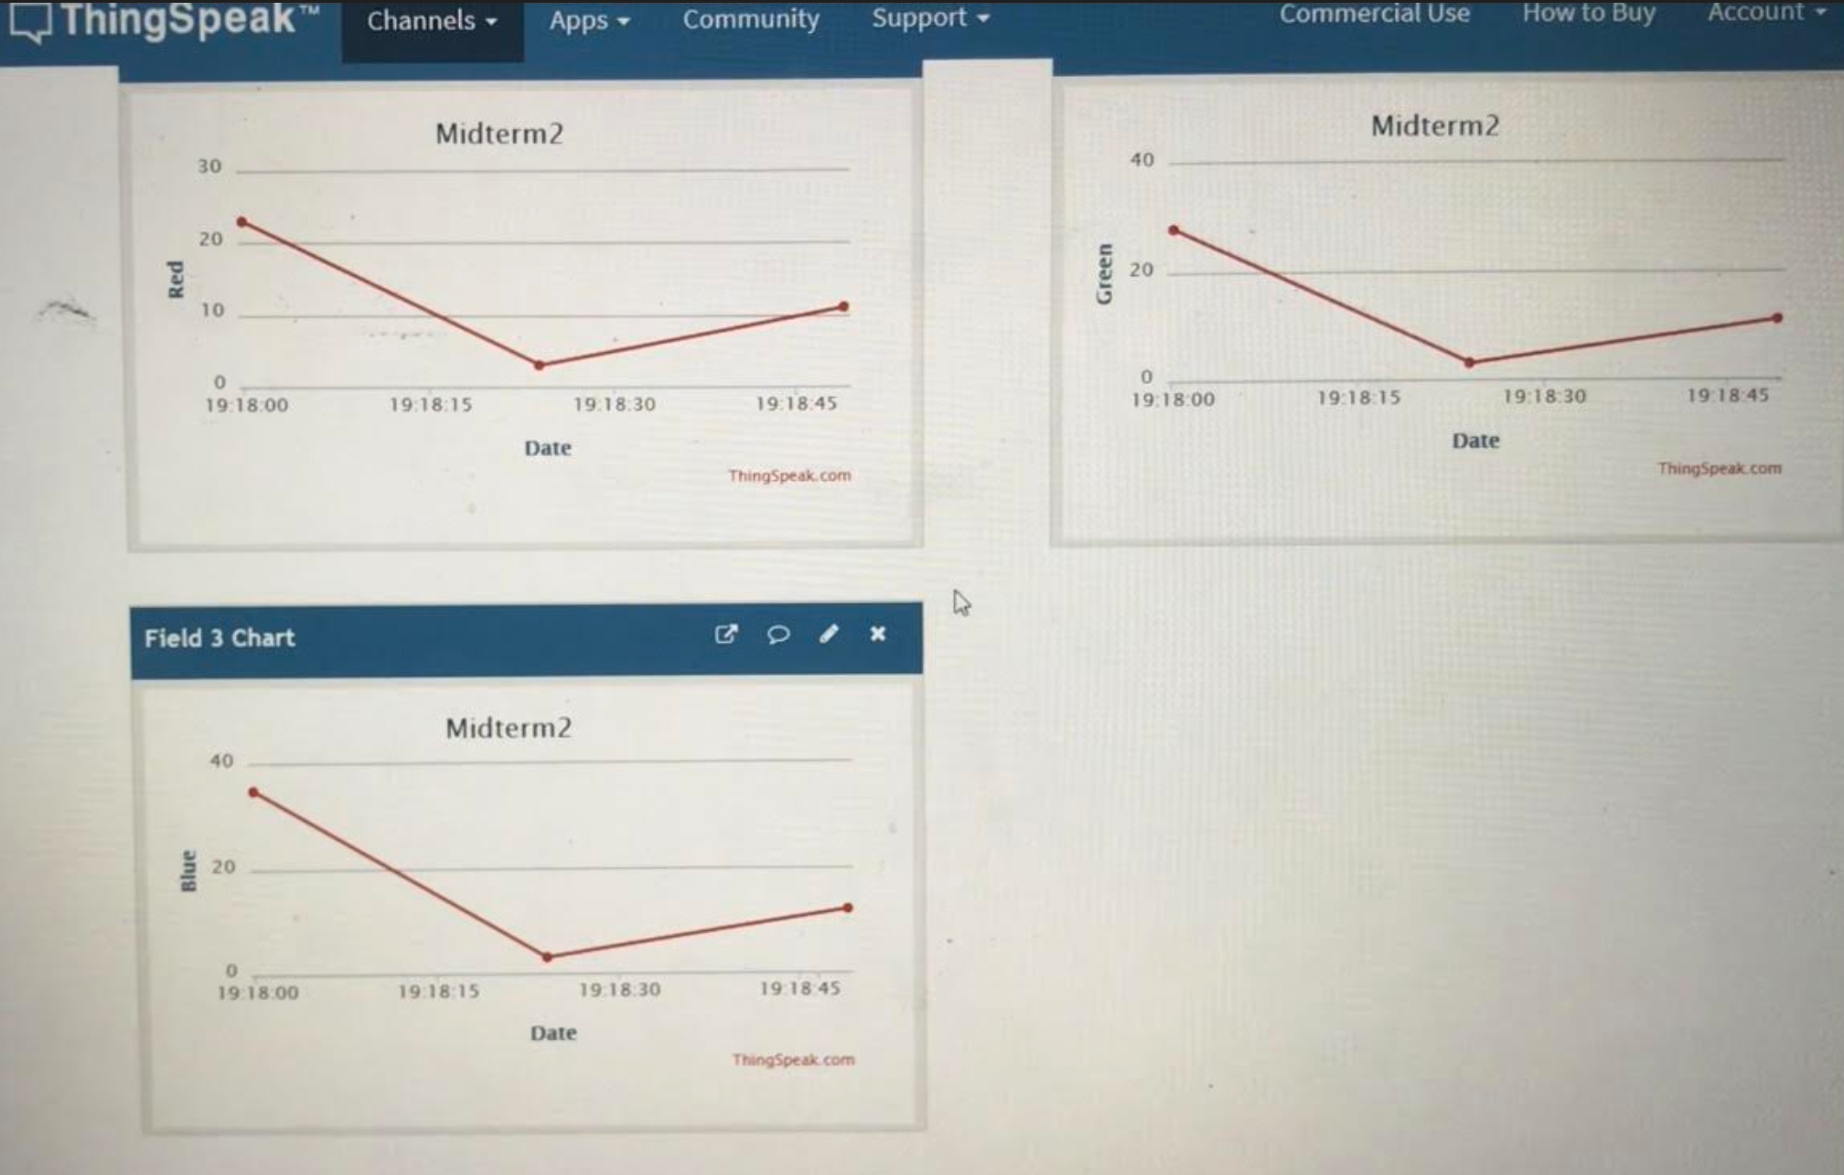

1. **SCREENSHOT OF EACH DEMO (BOARD SETUP)**

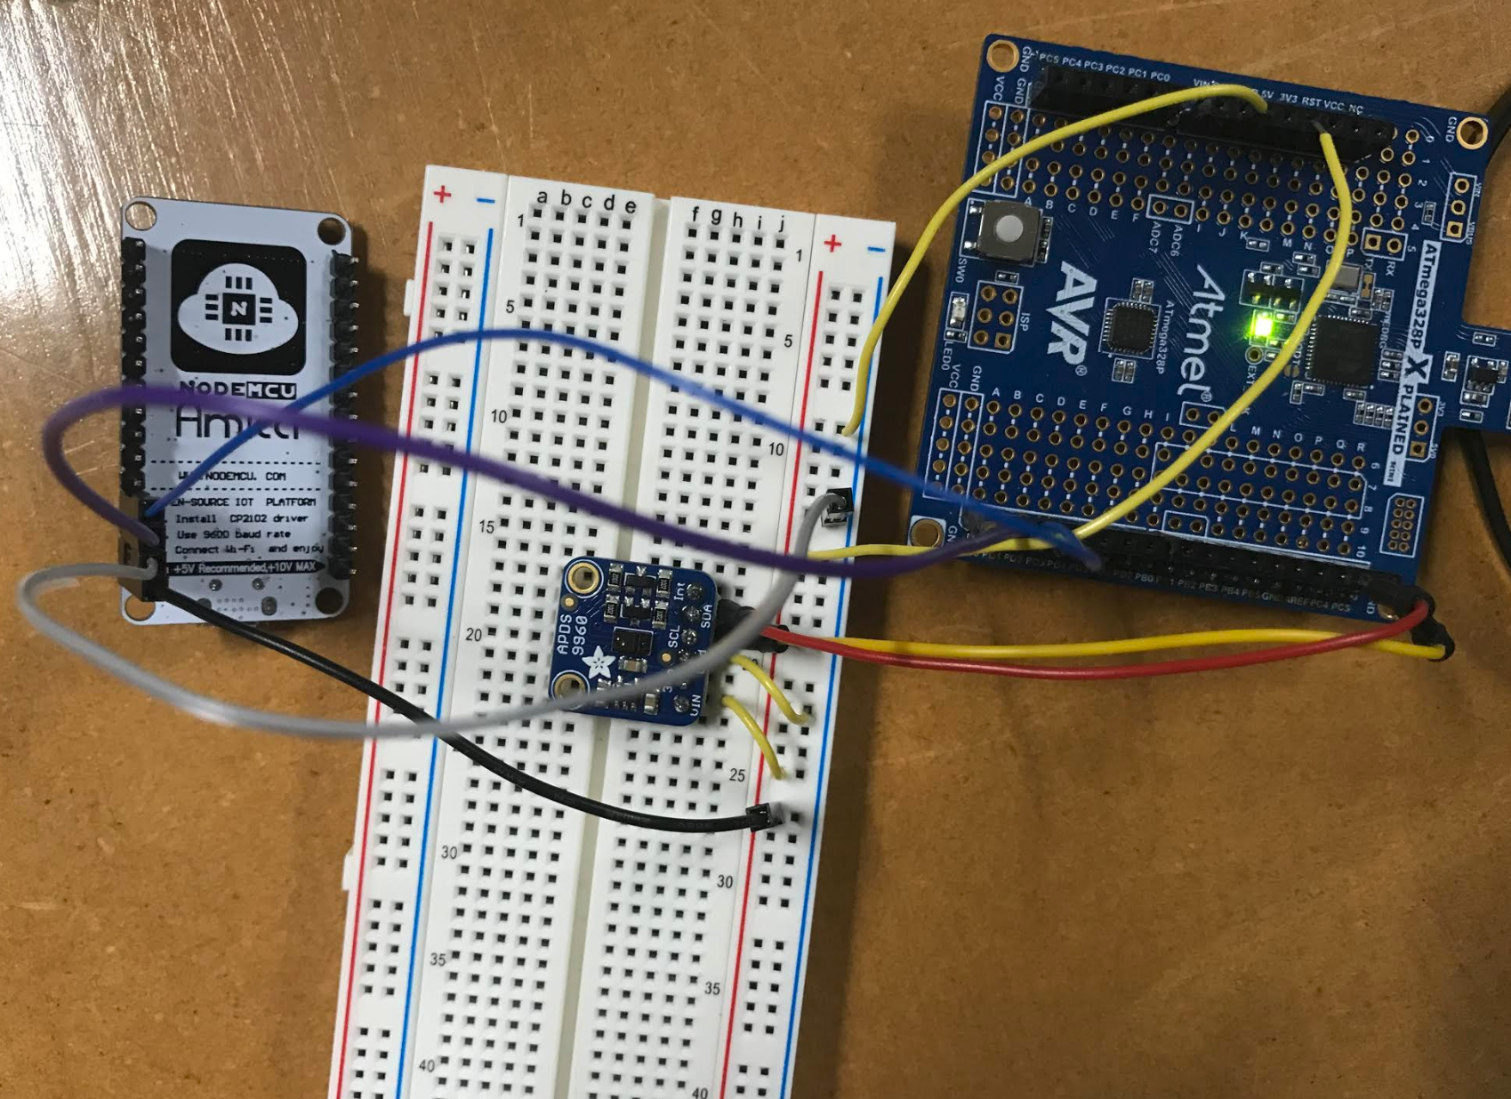

1. **VIDEO LINKS OF EACH DEMO**

[**https://youtu.be/dAISH9QtOwM**](https://youtu.be/dAISH9QtOwM)

1. **GITHUB LINK OF THIS DA**

<https://github.com/acexhp/submission_da.git>

**Student Academic Misconduct Policy**

<http://studentconduct.unlv.edu/misconduct/policy.html>

“This assignment submission is my own, original work”.

Allis Hierholzer